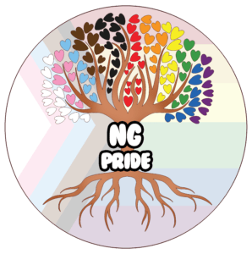 | NG PRIDE PARADE  REGISTRATION FORM  BUSINESS/COMMUNITY GROUP/CORPORATION** | 

Full Name of Business:
Name of Team Leader for this Group:
Phone Number of Team Leader:
How many individuals will be joining your group:
Address of Business:
Email Address:

PARADE INFO: | Are you a:
PARADE INFO: | ☐ Community Service ($25) | - Local Business ($50)
Payment via eTransfer to payments@ngpride.ca |  | - Corporation ($75)  SPONSORS - PAYMENT WAIVED

Have all participants read, signed, and acknowledged the "Release of Liability, Waiver of Claims, Assumption of Risks, Authorization, and Indemnity Agreement"?

PLEASE INITIAL: YES ______ NO ______

DATED at __________________ this ______ day of ____________, 2026.

______________________________________________________
PRINT NAME OF TEAM LEADER FOR GROUP

______________________________________________________
SIGNATURE OF TEAM LEADER FOR GROUP

